PROJECT REPORT

Project title: fruit shopping app
By: Manali Soni
Registration number :25BCE10898

INTRODUCTION:
The purpose of this project is to help the customer in buying fruits.it displays the menu of fruits with their prices .let the user select the select fruits and their quantity and add it to cart .When the user is done selecting items the app generates a bill in which the quantity is mentioned and the final amount to be Paid .Its purpose of creation is to create a real world style ordering system.

PROBLEM STATEMENT:
Design a simple fruit ordering app in python that displays a menu of fruits with their prices and allow the user to select quantity and store it in cart and also calculate the final bill and total amount to be paid.

REQUIREMENTS:
- Display a list of fruits with their prices .
- Accept the user input for selection
- Verify that the the selected fruit should exists in the menu.
- Store the quantity with fruit name in the cart.
- Calculate the cost for each .
- Display a final bill to be paid by the user .

Functional requirements :
The fruit ordering app allows users to view a fruit menu with names and prices, select fruits and quantities, add them to cart, update or remove items, see total amount, enter delivery details, place orders, view order confirmation and (optionally) see order history.
Admin/shop owner can add, edit or delete fruits, change prices and check customer orders.

Non-functional requirements:
The app should be easy to use, fast in loading screens and updating totals, reliable without frequent crashes, secure for user data, compatible with common devices, simple to maintain and able to handle more users and fruits in future.

ALGORITHM :

- Start
2)initialize menu dictionary with fruits and prices .
3)show welcome and then show menu .
4)create an empty cart dictionary .
5) repeat : ask the user to enter fruit name(or done to finish )
6)if Input is done ,exit loop.
7)if fruit is in menu :
Ask for the quantity and update the entry in cart.
Else show ‘‘invalid fruit’’
8)set total =0
9)display total amount with a message of thank you .
10) stop

FLOWCHART : 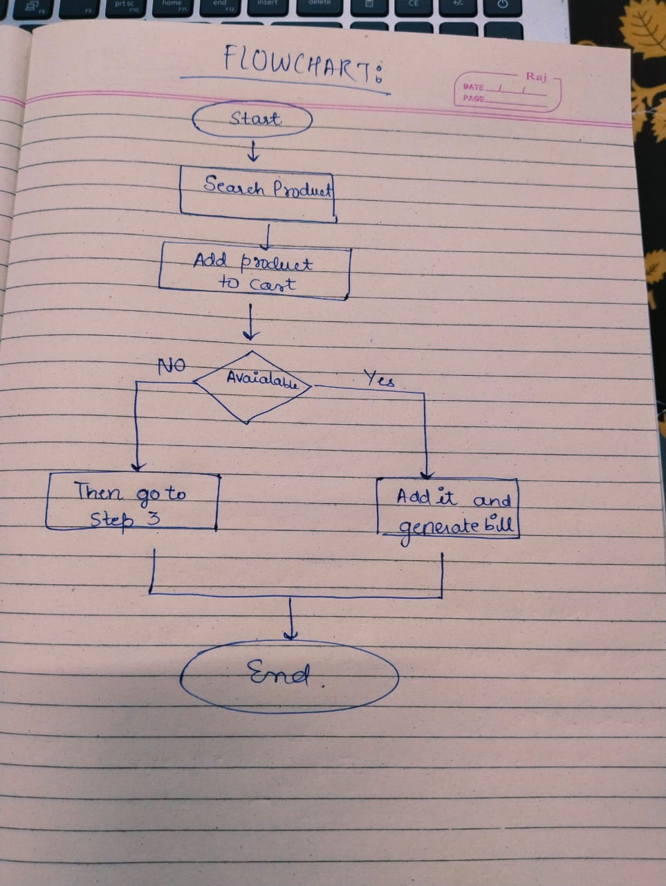

CODE :
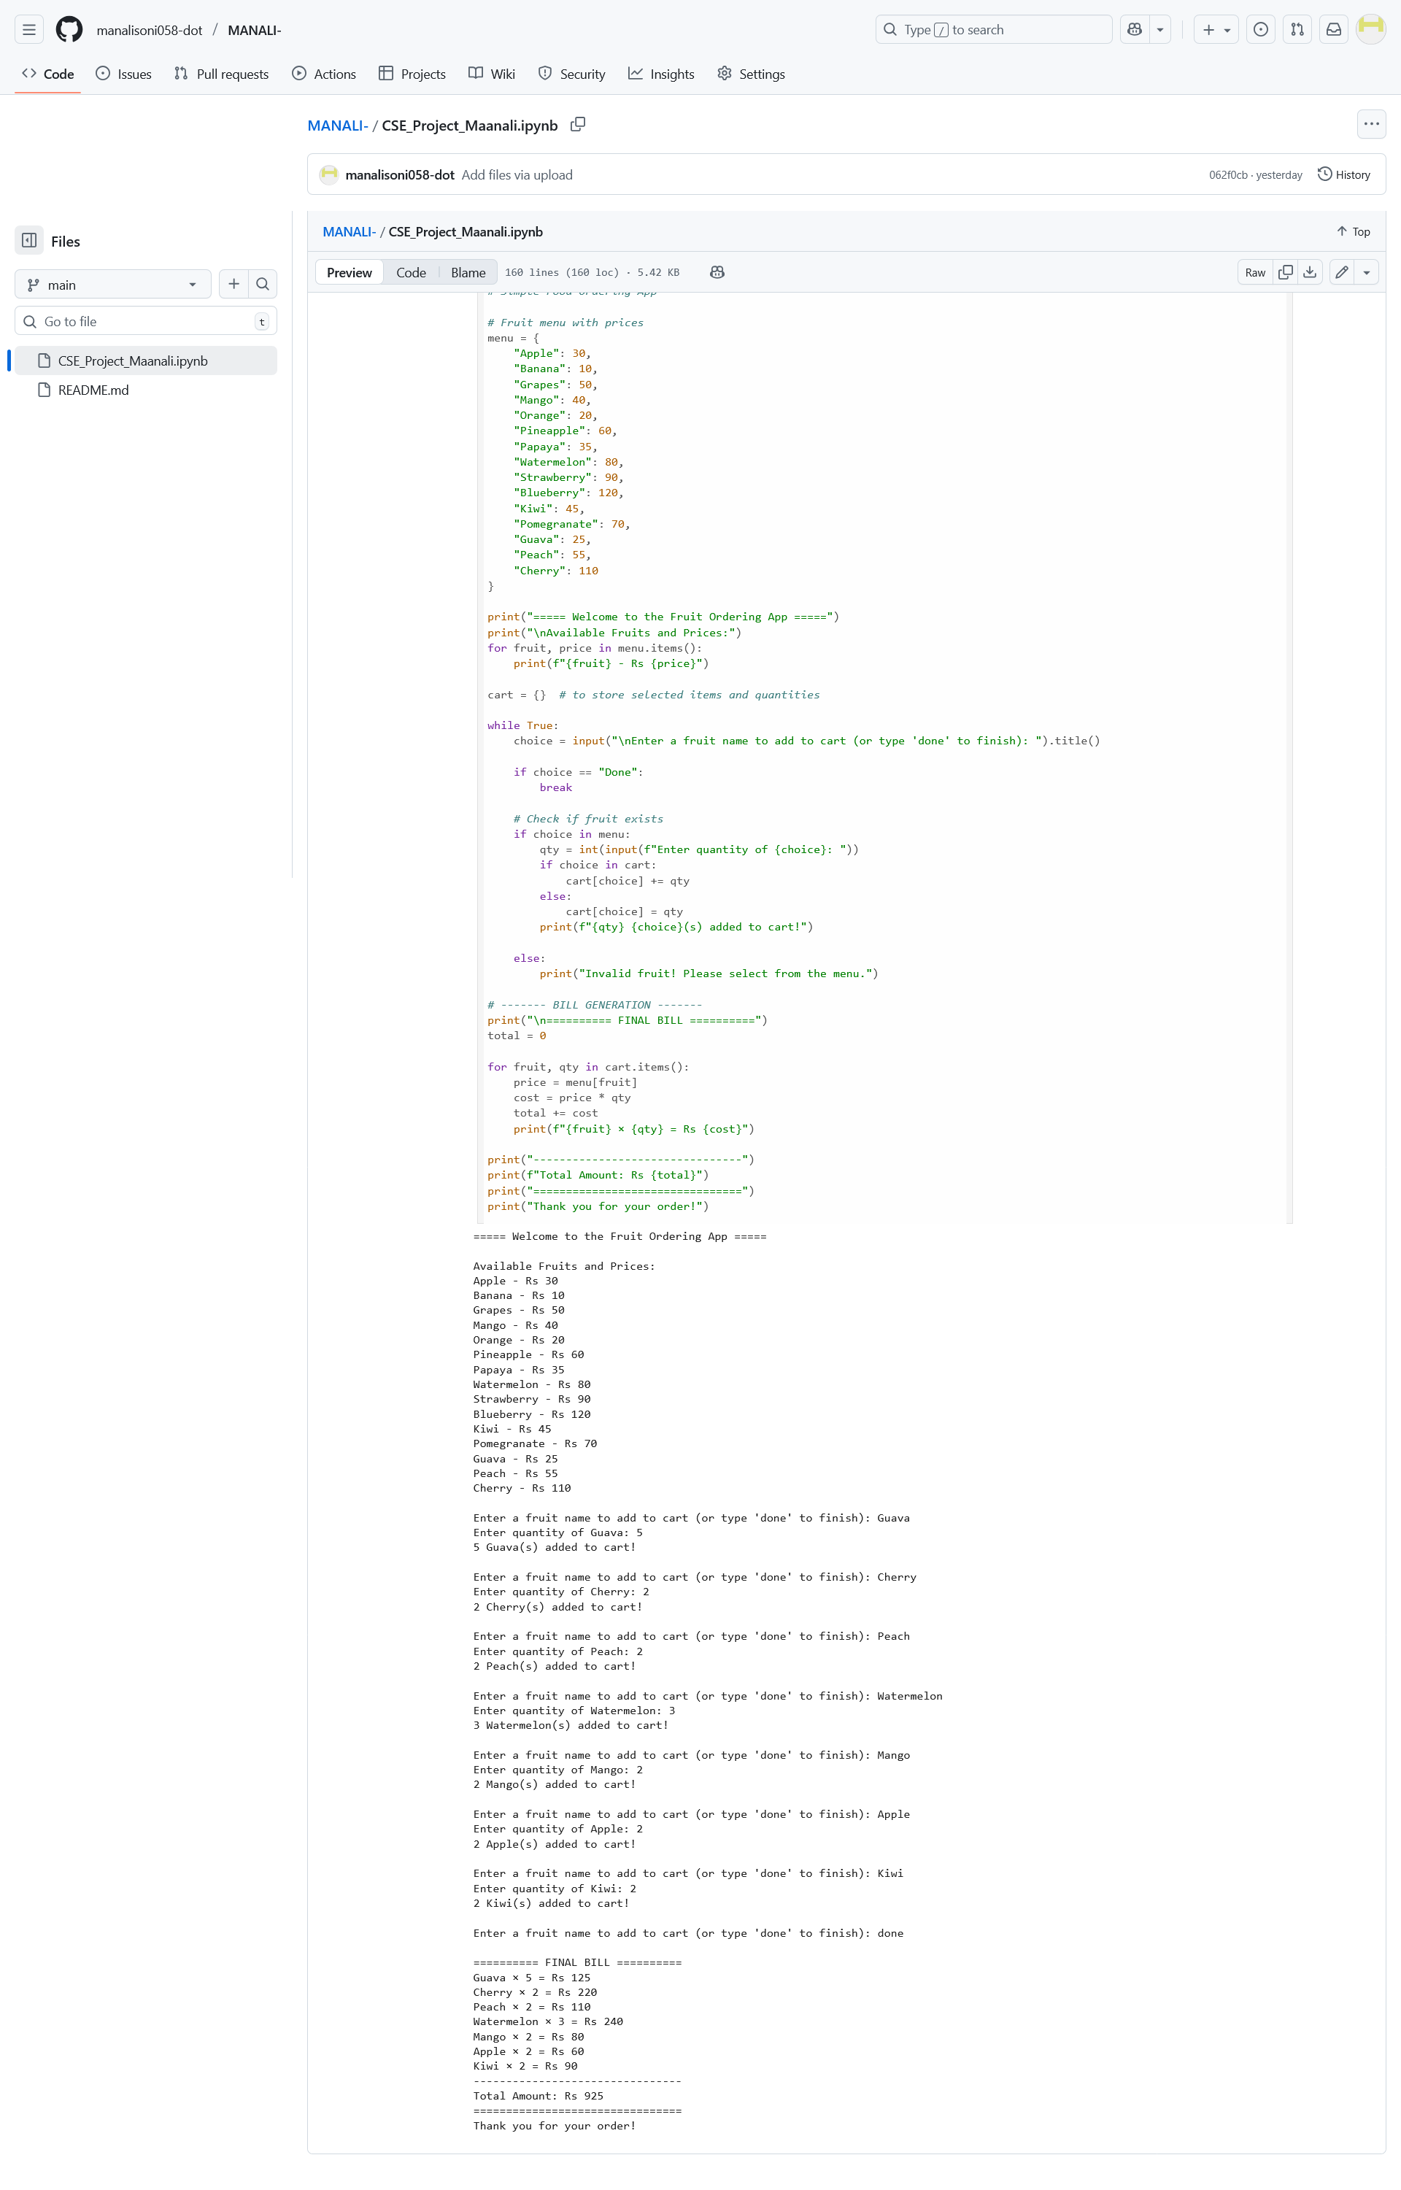
RESULT:
1)It shows a welcome message and fruit menu with their respective prices .
2)The user is required to type the name of the fruit and quantity of that fruit .
3) if the user types something not in menu then display invalid output and kindly select it from menu
4) print a final bill with each fruit quantity and cost.
5) finally print the total amount to be paid and print a thank you message .
6) its working smoothly and efficiently.

REFERENCE :
1)Python software foundation , python documentation – input and output ,available at : https://docs.python.org
2)python official documentation tutorials and VITyarthi.

